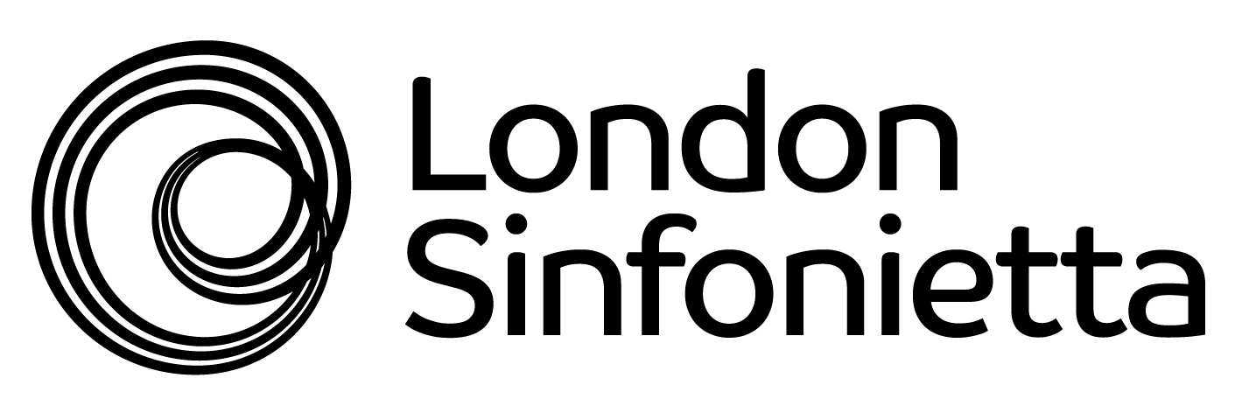
Writing the Future 2013
Application form


1. Personal details
Full name
Home address
Mobile phone no.
Home/alternative phone no.
E-mail address
Website address
Nationality
If you are not British then please state how long you have been resident / studying in this country and your anticipated stay in the UK between June and December 2013.

2. Expression of interest
Please indicate which Writing the Future opportunity/opportunities you would like to apply to.

Opportunity 1: solo commission with design collaboration | Yes | No
Opportunity 2: small chamber commission | Yes | No

3. Curriculum Vitae
Please send a copy of your professional CV with this application.

Please note that applications will not be accepted without this information.

4. Referee
Please confirm the name of a referee; a tutor, mentor or colleague in your discipline.
Please provide a contact phone no. and email address.

5. Personal Statement
If you are applying for opportunity 1 (solo commissions), please attach a personal statement of no more than 300 words. Describe what you hope to gain from participating in the Writing the Future initiative and any ideas on the kind of work that you would like to create on the programme.
Please note that applications for opportunity 1 (solo commissions) will not be accepted without this statement.

6. Availability
Please state any commitments that mean you will be unable to take part in scheme activities between June and December 2013. List these either on a weekly basis, or specific periods across these months when you will not be free.

Would you be available to attend an interview on X June 2013?

7. Examples of your work
Please list the 3 examples of your work that you are submitting to support your application. We are requesting a pdf score (as appropriate) and live recording of each work.
Title 1
Title 2
Title 3
Please confirm that the 3 examples are attached with you application.  Please note that Sibelius files must be converted to pdf documents in order to be considered. |  | 1. | Yes | No
 |  | 2. | Yes | No
 |  | 3. | Yes | No

8. Declaration
I confirm that all the information I have supplied in this application is true, and the examples of the work I have submitted are my own. I understand that any false information or plagiarism will result in this application being rejected outright.

Signature |  | Date

Submitting your application
Applications and supporting materials should be sent by email to:
now@londonsinfonietta.org.uk

The closing date for Applications is Friday 7 June 2013
Late applications will unfortunately not be accepted. Please aim to submit your application as far in advance of the deadline as possible to facilitate the processing of applications.

In you have any questions or enquiries about this initiative please contact:
now@londonsinfonietta.org.uk or 020 7239 9340.

Writing the Future is generously supported by The Boltini Trust, Anthony Mackintosh and Michael & Patricia McLaren-Turner.

